What is Inventory Management?

Ans: Inventory management is the process of ordering, handling/selling, storing.

inventory management is actually balancing right amount of stock, in the right place, at the right time.

Type of im?

Retail inventory management?

Retail is the general term used to describe businesses that sell physical products to consumers.

Retail can be split into several areas:

● Offline. Where a company sells via a brick-and-mortar store or physical location.

● Online. Where a company sells over the internet via an ecommerce website or marketplace.

**The importance of inventory management?**

A retail business is useless without its inventory.

Good inventory management helps with:

1. Good Customer experience.

If customer comes to me and asked for some product that should available. If it is not available then I should be able to give that product in given timeline by customer.

1. Improving cash flow.

Putting cash into too much inventory at once means it’s not available for other things - like payroll or marketing.

1. Avoiding shrinkage.

Purchasing too much of the wrong inventory and/or not storing it correctly can lead to it becoming ‘dead’, spoiled, or stolen.

**Project: Retail inventory Management in Offline Mode**

Problem Statement:

Its very difficult to manage stock details like products, its available quantity, actual orders for a retail shop/small business. Even if manage using logbooks but it becomes difficult to get information about any product in less time. Some time wrong products or same products are getting order because of less visibility or wrong entry in logbook. This also leads to unnecessary cash flow and low storage space. Customer satisfaction also hampers and hence business.

Solution/Aim: Creating a retail inventory management system that can improve customer satisfaction and hence business by keeping track of suppliers, products, stocks, customers and orders. The System will help in balancing the right amount of stocks and improves the cash flow and storage.

Data Model:

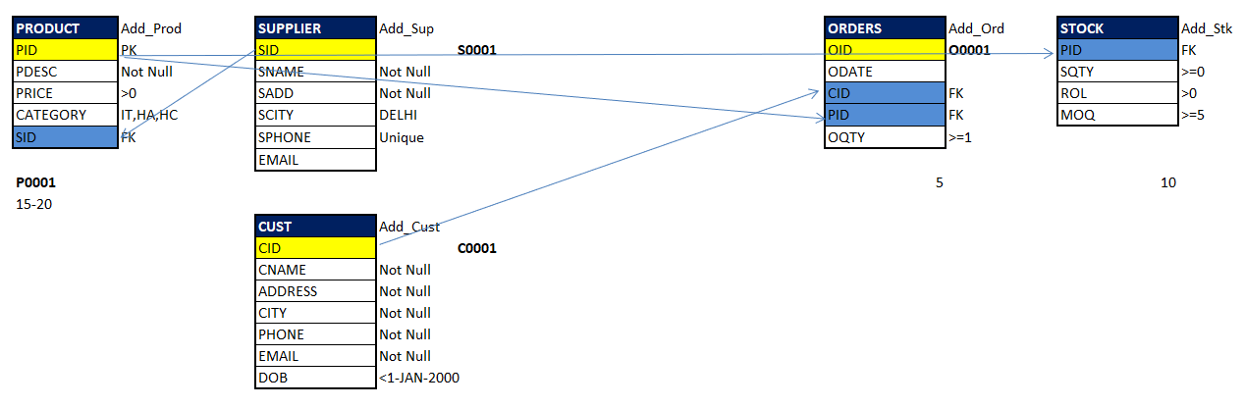

Features: